TECHNICAL SPECIFICATION FOR MANHOLE COVER
Model 660 x 660 mm – 400kN Composite cover
 | Description | Unit | Requirement | Supplier’s Offer
1 | Manufacturer
2 | Dimension | mm | 660 x 660
3 | Material |  | Composite
4 | Nominal load |  | D400kN
5 | Quality (standard) |  | D400, SIST EN124
6 | Dimension A (clear dimension) | mm | 660
7 | Dimension B (clear dimension) | mm | 660
8 | Dimension h (thickness) | mm | based on nominal load
9 | Top description |  | 20 kV 400kN  ELEKTRIKA
10 | Safety |  | Locking with bolt
11 | Weight | kg | based on nominal load

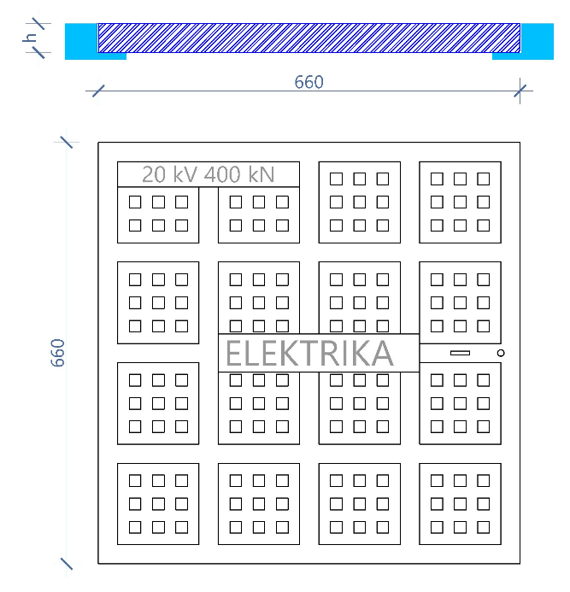

Notice
- Prefabricate cover manhole must be prepared based on technical detail,
- The cover should also have a rectangular opening hole,
- The Supplier must give the information based on all 11 description mentioned on the tech. spec. table, on suppliers offer section.
  - Information regarding the technical specification on Weight and Thickness dimensions must be based on NOMINAL LOAD REQUIREMENT D400kN.
- The supplier must also provide a catalog, ISO certificates and required attest about the products.

